**OOP LAB**

**Lab Report No. 02**

**Submitted By: Jamshid Bacha**

**Regesteration No. 16PWCSE1404**

**Submitted To: Engr. Sumayya Salahuddin**

**Section: B**

**Batch: 18**

**Department: CSE**

**Date: 06-10-2017**

**University of Engineering and Technology Peshawar**

**Home-Task**

**Task 01**

**CODE:**

#include<iostream>

using namespace std;

class complex

{

private:

float real,imag;

public:

complex()

{

real=0;

imag=0;

}

complex(float r,float i)

{

real=r;

imag=i;

}

// Using Friend Function:

void sum(complex c1,complex c2)

{

real = c1.real + c2.real;

imag = c1.imag + c2.imag;

}

void sub(complex c1,complex c2)

{

real = c1.real - c2.real;

imag = c1.imag - c2.imag;

}

void multiply(complex c1,complex c2)

{

real=c1.real*c2.real - c1.imag*c2.imag;

imag=c1.real*c2.imag + c1.imag*c2.real;

}

void show()

{

cout<<endl<<real<<" , "<<imag<<"i"<<endl;

}

};

int main()

{

float real,imag;

cout<<"Enter First complex Number: "<<endl;

cout<<"Real Part: ";

cin>>real;

cout<<"Imagenary Part: ";

cin>>imag;

complex c1(real,imag);

cout<<endl<<"Enter Second complex Number: "<<endl;

cout<<"Real Part: ";

cin>>real;

cout<<"Imagenary Part: ";

cin>>imag;

complex c2(real,imag),c3;

cout<<"Sum of Two Complex Numbers: "<<endl;

c3.sum(c1,c2);

c3.show();

cout<<endl;

cout<<"Subtraction of Two Complex Numbers: "<<endl;

c3.sub(c1,c2);

c3.show();

cout<<endl;

cout<<"Multiplication of Two Complex Numbers: "<<endl;

c3.multiply(c1,c2);

c3.show();

cout<<endl;

return 0;

}

**RUN**

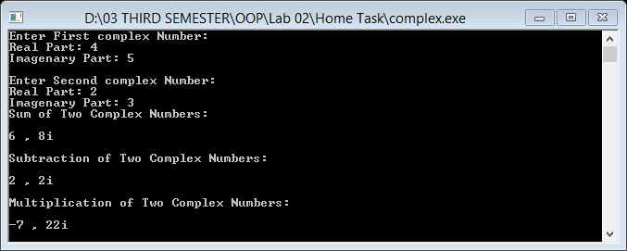

**Task 02**

**CODE:**

#include<iostream>

#include<string>

using namespace std;

class Employee

{

private:

string F_name,L_name;

double salary;

public:

Employee()

{

F_name="";

L_name="";

salary=0.0;

}

void set_Data()

{

cout<<"Enter Farst Name: "<<endl;

cin>>F_name;

cout<<"Enter Last Name: "<<endl;

cin>>L_name;

cout<<"Enter Salary: "<<endl;

cin>>salary;

if(salary<0)

{

salary=0.0;

}

}

void get_Data()

{

cout<<endl<<"Name of Employe: "<<F_name<<" "<<L_name<<endl;

cout<<"Monthly Salary: "<<salary<<endl;

}

void raise_Salary()

{

salary+=salary/10;

}

void Year_Salary()

{

cout<<"Yearly Salary Is: "<<salary*12<<endl;

}

};

int main()

{

Employee employee1,employee2;

cout<<"Enter First Employee Information: "<<endl;

employee1.set_Data();

cout<<endl<<"Enter Second Employee Information: "<<endl;

employee2.set_Data();

cout<<endl<<"First Employee Information: "<<endl;

employee1.get_Data();

employee1.Year_Salary();

cout<<endl<<"Second Employee Information: "<<endl;

employee2.get_Data();

employee2.Year_Salary();

cout<<"After One Year: "<<endl;

cout<<endl<<"First Employee: ";

employee1.Year_Salary();

cout<<endl<<"Second Employee: ";

employee2.Year_Salary();

return 0;

}

**RUN:**

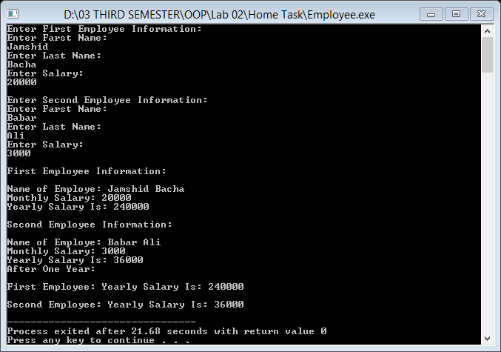

**Task 03**

**CODE:**

#include<iostream>

using namespace std;

class Date

{

private:

int day,month,year;

public:

Date()

{

day=0;

month=0;

year=0;

}

void setData(int d,int m,int y)

{

day=d;

month=m;

year=y;

}

int getday()

{

return day;

}

int getmonth()

{

return month;

}

int getyear()

{

return year;

}

void show()

{

cout<<endl<<"Date: "<<day<<" / "<<month<<" / "<<year<<endl;

}

};

int main()

{

Date obj;

int d,m,y;

cout<<"Enter Day: ";

cin>>d;

cout<<"Enter Month: ";

cin>>m;

cout<<"Enter Year: ";

cin>>y;

obj.setData(d,m,y);

obj.show();

return 0;

}

**RUN:**

